PAYROLL EXPENSES – Proof of Payment:
Example if Payroll System is being utilized to cut payroll checks, then there may be a Report similar to this that can be used as Proof of Payment.
This example hits the following requirements:
1) Name of Employee
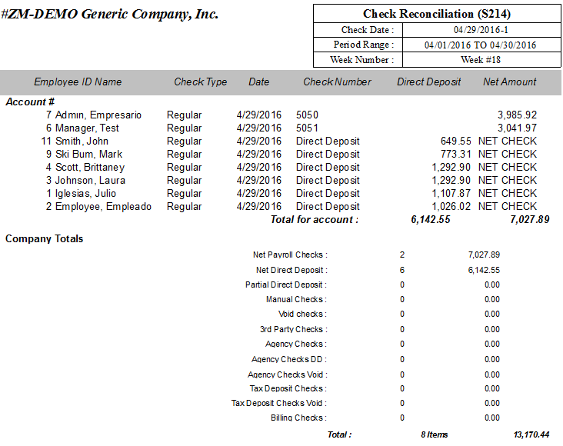
2) Date of Payment
3) Pay Period Covered
4) Amount of payment
5) Check/Deposit Data

PAYROLL EXPENSES – Proof of Payment (continued):
Example if Payroll System is being utilized to cut payroll checks, if payroll report as exampled above is not available then can use check stub as Proof of Payment.
This example hits the following requirements:
1) Name of Employee
2) Date of Payment
3) Pay Period Covered
4) Amount of payment
5) Check/Deposit Data

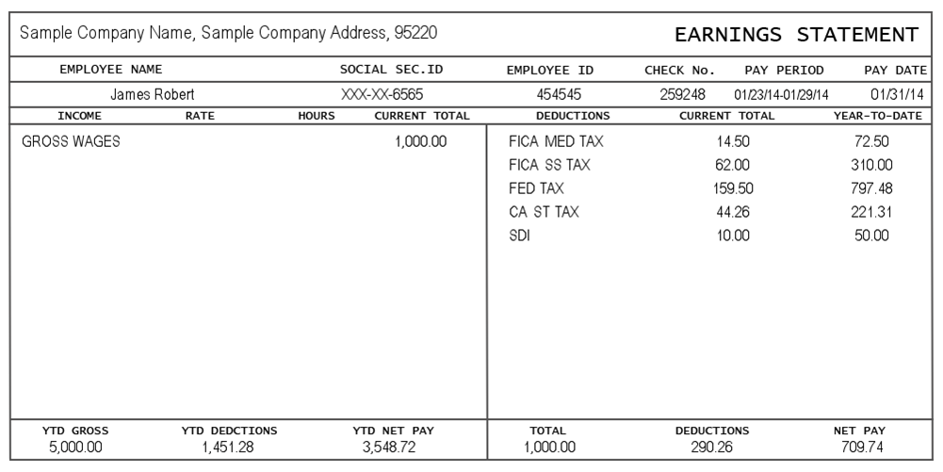
PAYROLL EXPENSES – Proof of Payment (continued):
Example if Checks are being handwritten for Payroll, can use check stubs.
(Other options: Carbon Copy of Check/Canceled Check/Bank Statement reflecting the cleared check)
This example hits the following requirements:
1) Name of Employee
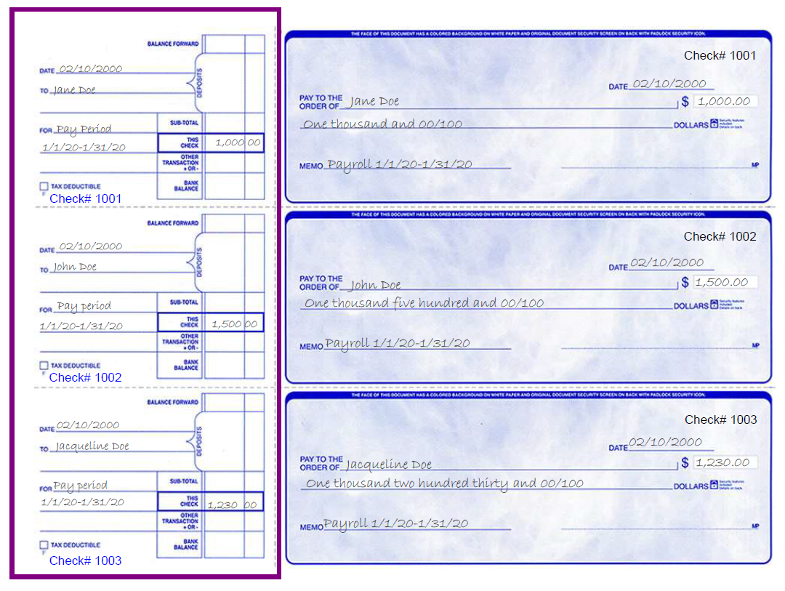
2) Date of Payment
3) Pay Period Covered
4) Amount of payment
5) Check Data

MILEAGE EXPENSES – Mileage Log:
Example of mileage log as Supporting Document.
*PROOF OF PAYMENT OPTIONS ARE THE SAME AS FOR PAYROLL.
This example hits the following requirements:
1) Name of Employee/Driver
2) Date of Travel
3) To/From Locations
4) Miles traveled
5) Total Mileage Cost (mileage multiplied by current IRS rate)
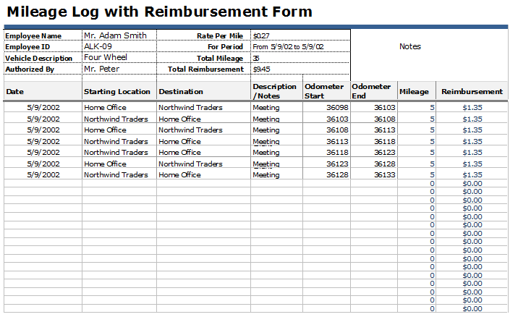
PURCHASES & SERVICES EXPENSES:
Example of itemized receipt or invoice from the vendor as Supporting Document.
*PROOF OF PAYMENT (if not already indicated on receipt) OPTIONS ARE THE SAME AS FOR PAYROLL.
This example hits the following requirements:
1) Document clearly indicates the grant expense and amount of expense
2) Document clearly indicates the date of purchase/service
