**Homelessness in Kitsap County**

*Updated: September 2017*

***Households Experiencing Homelessness Rising***

The Housing Solutions Center reports 1,086 literally homeless households during 2016 that were seeking housing assistance, 675 households at imminent risk of losing housing, and 1,045 that were unstably housed and seeking assistance. 2016 Total = 2,806 households.

(Housing Solutions Center of Kitsap County)

***88% Affordable Housing Gap***

For every 100 very low-income households who need affordable housing, there are only 12 units available; for low-income households, there are only 32 units available. The total number of very low-income renter households is 6,095 ($22,600/year); there are 5,500 low-income households ($37,800/year).

(2015 Washington Affordable Housing Needs Assessment)

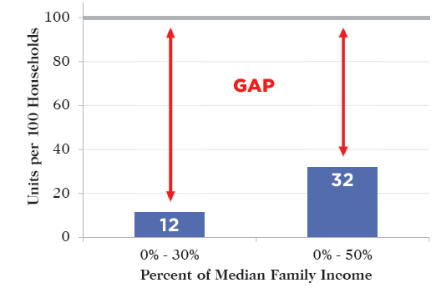



**Individuals** experiencing homelessness during a 24-hour period decreased 3% between 2016 (647 people) and 2017 (626) and increased 26% between 2015 (496) and 2017. (Kitsap Annual Point in Time Count, *2017 certified data*)

***Housing Instability for 13,875 Renter Households***

Many households are paying more than 30% (*cost burdened*) or 50% (*severely cost burdened*) of their income on housing, creating housing instability and loss of housing during household crises.

(2015 Washington Affordable Housing Needs Assessment)

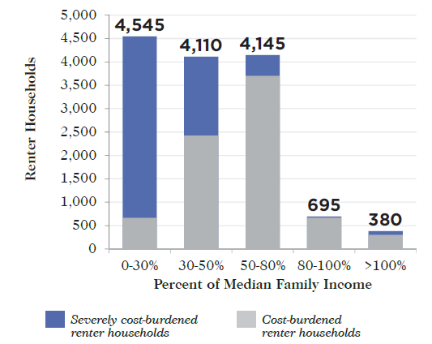

***Unsheltered Homeless Individuals Increasing***

Households living without shelter in places not meant for human habitation (outside, abandoned buildings, cars) has decreased 9% between 2016 and 2017 in the annual Point In Time Count (24-hour census of people experiencing homelessness).

***Rental Rates Increasing as Vacancy Rates Decline***

The average unit rent increased $332 (37%) since the beginning of 2014, while vacancy rates fell to 4.55%.

(Apartment Insights Washington)

*\*2017(S) – 2017 Summer Point in Time Count*

***Some Households Moving Out of Homelessness***

During 2016, 2,706 households were referred to housing programs in the Kitsap Homeless Crisis Response System (comprised of more than 20 different programs). However, another 428 households (11% of those seeking assistance) were unable to be served because resources were not available to meet their needs and 356 (10%) were unable to be assisted immediately and were placed on a waitlist.

(Kitsap Homeless Response System Performance Dashboards))

***20% of Affordable Housing Units Disappearing***

Between 2015 – 2017, 867 units of approximately 4,272 affordable housing units currently available are projected to be lost due to expiring restrictions on rental rates and existing subsidy programs ending.

(2015 Washington Affordable Housing Needs Assessment)

***Wages Not Keeping Pace with Housing Costs***

The average wage earned by Kitsap renters is $11.94, which is not enough to afford even a zero bedroom home. For minimum wage earners the gap is even wider – at minimum wage ($11.00 in 2017) a household had to work 73 hours a week to afford a two-bedroom unit. To pay no more than 30% of their income on housing for a two-bedroom apartment, the housing wage is $19.98.

(2017 Out of Reach Report)

**What We Are Doing to Help People Experiencing Homelessness**

* Kitsap has a single point of entry for any individuals or households who are experiencing homelessness or housing instability, called the Housing Solutions Center, 360-473-2035.
* Over 50 organizations participate in the Kitsap Continuum of Care Coalition, a network of housing and social service providers assisting people experiencing homelessness and housing instability.
* Kitsap has a variety of subsidized housing options, including:
  + 130 emergency shelter beds (up to 90 days)
  + 102 Transitional Housing units (up to 24 months)
  + 273 Permanent Supportive Housing units (for people who need on-going case management)
  + 2719 Permanent Subsidized Housing units (for low-income households)
  + 1877 Housing Choice and Veterans Assistance Housing Vouchers (providing rental subsidies)
* Each year, Kitsap organizations receive funding for homeless programs, including (2015 amounts):
  + Federal Funding: $673,107
  + Federal Veteran Funding: $1.3M
  + State Funding: $499,688
  + Local Funding: $1.1M
* In 2016 Kitsap organizations provided housing and homeless services for more than 2,700 households; affordable housing subsidies providing an additional 4,500 low-income households with stable housing.

Kirsten Jewell, Coordinator

360-337-7286

[kjewell@co.kitsap.wa.us](mailto:kjewell@co.kitsap.wa.us)

**Kitsap County Department of Human Services**

Housing & Homelessness Program

345 6th Street, Suite 400

Bremerton, WA  98337

